Name of the Student: G. Manasa | Academic Year: 2025-26
Student Registration Number: 241U1R3007 | Year & Term: II & I
Study Level: UG | Class & Section: CSE-DS -2A
Name of the Course: FOUNDATION OF DATA  SCIENCE | Name of the Instructor: Mr. Pranay Vemula, Assistant Professor, CSE.
Name of the Assessment: Assignment 1 | Date of Submission: 03-11-2025

Assignment- 1

- Explain the significance of AI in Data Science.

Significance of AI in Data Science
Artificial Intelligence (AI) is very important in Data Science because it helps us understand data better, make smart predictions, and even automate work that would take a long time to do by hand. Here’s why it matters:

1. Automating Data Work
AI can automatically clean, sort, and study large amounts of data much faster and more accurately than people. This saves time and lets data scientists focus on finding useful insights instead of doing boring, repetitive work.

2. Making Better Predictions
AI especially machine learning helps computers learn from data and make predictions.
For example:
- Predicting what customers might buy next
- Guessing future stock prices
- Helping doctors find diseases
The more data these models get, the smarter and more accurate they become.

3. Helping in Decision-Making
AI finds hidden patterns in data that humans might miss. This helps companies make better, data-based decisions instead of guessing or relying only on experience.

4. Managing Big Data
Today, data comes from everywhere phones, sensors, social media, and more. AI can handle this huge amount of data and quickly turn it into useful information.

5. Real-Time Analysis
AI can study data as it’s being created (in real time). This is used in:
- Detecting fraud while it happens
- Suggesting videos or products (like Netflix or Amazon)
- Controlling self-driving cars

6. Understanding Text and Images
AI helps computers understand unstructured data such as text, images, and videos.
Examples:
- NLP (Natural Language Processing) helps read and understand text (like analyzing customer reviews).
- Computer Vision helps recognize faces or objects in pictures.

7. Learning and Improving Over Time
AI systems can learn from new data and keep improving automatically. They don’t always need humans to update them.

- Describe the functions of the NumPy library in Data Science.

Functions of the NumPy Library in Data Science
NumPy (Numerical Python) is one of the most important libraries used in Data Science. It helps with fast mathematical calculations, data storage, and data manipulation. Here are some of its main functions:

1. Handling Arrays and Matrices
NumPy provides a special data structure called an ndarray (N-dimensional array).
It allows you to store and work with large amounts of numerical data efficiently — much faster than using normal Python lists.

2. Mathematical and Statistical Operations
NumPy has built-in functions for performing:
- Addition, subtraction, multiplication, and division on arrays
- Mean, median, standard deviation, and variance
- Complex mathematical operations like trigonometry and logarithms
These are very useful for analyzing and processing data.

3. Data Cleaning and Transformation
NumPy helps clean and prepare data by:
- Handling missing or invalid values
- Reshaping or slicing arrays
- Converting data types (like changing integers to floats)

4. Integration with Other Libraries
NumPy is the foundation for many other Data Science libraries like:
- Pandas (for data analysis)
- Matplotlib (for data visualization)
- Scikit-learn (for machine learning)
These libraries use NumPy arrays to handle data efficiently.

5. Linear Algebra and Matrix Computation
NumPy can perform advanced operations like:
- Matrix multiplication
- Finding determinants and inverses
- Solving linear equations
These are essential in fields like machine learning and data modeling.

6. Random Number Generation
NumPy’s random module can generate random numbers, which are often used for:
- Creating sample data
- Splitting datasets into training and testing parts
- Running simulations

- How does Frequency Distribution help in data analysis? Explain.
A frequency distribution helps in data analysis by arranging large amounts of data in a simple and easy-to-understand way. It shows how many times each value or range of values appears in a dataset, which helps us find patterns and trends easily. Instead of looking at a list of random numbers, the data is grouped into classes or intervals, like marks between 0–10, 11–20, and so on. This makes it easy to see where most of the data lies and how it is spread out. Frequency distribution is also used to create graphs like histograms and bar charts, which make the data clearer and more visual.

- Implement PCA and plot the results using Python.

PCA (Principal Component Analysis) reduces data dimensionality while preserving variance.

Python Implementation:
import numpy as np
import pandas as pd
from sklearn.decomposition import PCA
from sklearn.preprocessing import StandardScaler
import matplotlib.pyplot as plt
from sklearn.datasets import load_iris
data = load_iris()
X = pd.DataFrame(data.data, columns=data.feature_names)
X_scaled = StandardScaler().fit_transform(X)
pca = PCA(n_components=2)
X_pca = pca.fit_transform(X_scaled)

plt.scatter(X_pca[:, 0], X_pca[:, 1], c=data.target)
plt.xlabel('Principal Component 1')
plt.ylabel('Principal Component 2')
plt.title('PCA Result on Iris Dataset')
plt.show()

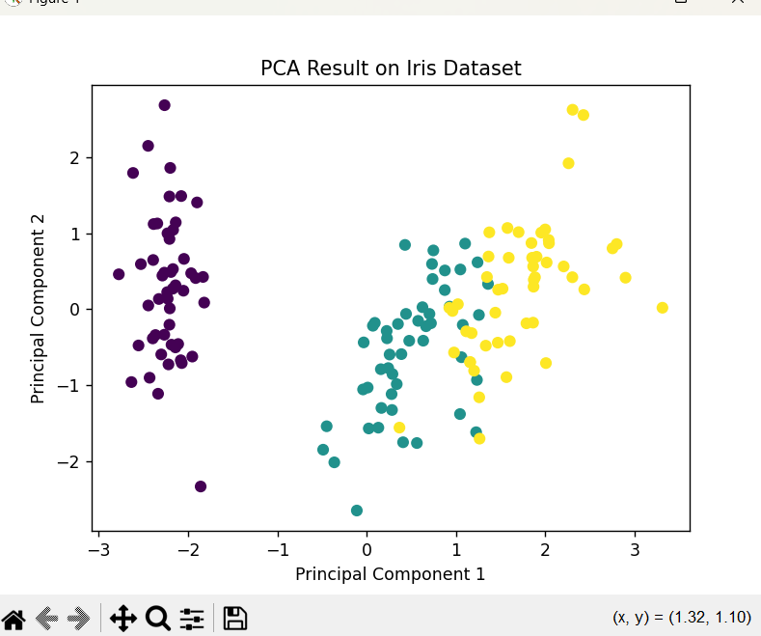

- Implement Lasso Regression using a dataset.

Lasso Regression (Least Absolute Shrinkage and Selection Operator) adds L1 regularization to reduce overfitting.

Python Implementation:
import pandas as pd
from sklearn.model_selection import train_test_split
from sklearn.linear_model import Lasso
from sklearn.metrics import mean_squared_error
from sklearn.datasets import load_diabetes
data = load_diabetes()
X = pd.DataFrame(data.data, columns=data.feature_names)
y = data.target
X_train, X_test, y_train, y_test = train_test_split(X, y, test_size=0.2, random_state=42)
lasso = Lasso(alpha=0.1)
lasso.fit(X_train, y_train)
y_pred = lasso.predict(X_test)
print("Mean Squared Error:", mean_squared_error(y_test, y_pred))
print("Coefficients:", lasso.coef_)

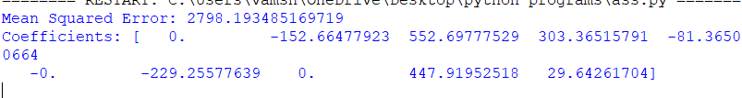

- Explain different ways to sort and filter data in Pandas. C

1. Sorting Data
Sorting in Pandas means arranging data in a specific order either ascending (small to large) or descending (large to small). It helps to organize and analyze data more easily.
Pandas allows you to sort data in a Data Frame using two main methods:

a) sort_values()
This function sorts data based on one or more columns.
import pandas as pd
data = {'Name': ['Alice', 'Bob', 'Charlie', 'David'],
'Age': [25, 30, 22, 35],
'Score': [85, 90, 75, 95]}

df = pd.DataFrame(data)
print(df.sort_values(by='Age'))
print(df.sort_values(by='Score', ascending=False))
b) sort_index()
This function sorts the DataFrame based on its row index.
print(df.sort_index(ascending=False))

2. Filtering Data
Filtering in Pandas means selecting specific rows from a DataFrame that meet certain conditions. It helps to focus only on the data that is important for analysis.
There are different ways to filter data:

a) Conditional Filtering
You can use logical conditions to filter rows.

print(df[df['Age'] > 25])
print(df[df['Score'] >= 90])

b) Filtering with Multiple Conditions
Use & (and), | (or) operators for combining conditions.

print(df[(df['Age'] > 25) & (df['Score'] > 85)])

c) Using query()
The query() method makes filtering easier to read.
print(df.query('Age > 25 and Score > 85'))

- What are the key differences B/W Predictive and Prescriptive Analytics?

1. Predictive Analytics
Predictive Analytics is the process of using historical data, statistics, and machine learning techniques to make predictions about future events or outcomes. It focuses on identifying patterns and relationships in existing data to forecast what is likely to happen next.
It does not tell you what actions to take it only helps in understanding future possibilities and trends.
Example:
- A bank predicting which customers are likely to miss loan payments.
- A retail store forecasting next month’s sales.
- A hospital predicting which patients are at higher risk of certain diseases.

2. Prescriptive Analytics
Prescriptive Analytics is a more advanced stage of analytics that goes beyond prediction. It not only tells what might happen, but also what actions should be taken to achieve the best possible results or outcomes.
It combines data, algorithms, and business rules to recommend specific decisions or strategies. It often uses techniques such as optimization, simulation, and machine learning to find the best solution from several possible options.
Example:
- An airline deciding optimal ticket prices to maximize revenue.
- A logistics company finding the most efficient delivery routes.
- A hospital scheduling staff to ensure maximum efficiency with minimum cost.

